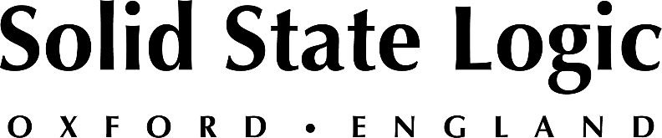

**AES NY 2023: Solid State Logic to Debut New Hardware and Software,**

**While Showcasing Next-Gen Analogue and Digital Consoles and Range of Controllers / Plug-Ins**

*SSL to share booth space with recently acquired Harrison; come visit legendary   
Nashville and Oxford-based audio brands in New York City – Use SSL guest pass code NY8373*

**New York, NY, September 21, 2023 — Solid State Logic [Booth 824] looks forward to meeting with customers, partners, old friends and new at AESNY 2023, scheduled to take place between Wednesday, October 25th and Friday, October 27th at the Javitz Center in New York City. SSL is delighted to share the exhibition floor with legendary audio brand Harrison, which SSL acquired in April of 2023.**

As in prior years at AES, SSL will be debuting new hardware and software during the show. Developed from the company's rich heritage in analogue console design, the forthcoming hardware brings a new range of sonic possibilities and workflows to the discerning recording engineer. Meantime, SSL is committed to keeping its range of controllers and software at the forefront of audio technology. Please stop by the SSL booth to learn more about its range of class-leading software, including SSL 360° and Complete suite of plug-ins.

**Hybrid production tools, analogue consoles and more**

Also at the AES booth, SSL will be showcasing the latest hybrid production tools including its UF1, and UC1 controllers, as well as its FUSION processor and THE BUS+ compressor. ORIGIN 16, which launched at AES last year to industry acclaim, will be available for demonstration with a UF8 controller integrated into the console's center section. ORIGIN + UF8 delivers legendary SSL analogue sound combined with advanced DAW control. At AES NY, SSL will be highlighting how this combination presents ‘the best of both worlds’ for producers and engineers.

**Next-gen immersive music production**

System T for music combines market-leading 9.1.6 monitoring, cutting-edge digital audio handling and advanced production workflows, including Dolby Atmos, with legendary SSL production tools optimized for immersive music. The large-format, modular S500 console will be available for demonstration at AES NY 23. Stop by and experience how System T for music allows producers, engineers, and facilities to produce cutting-edge music and immersive content, quickly, efficiently and with stunning sonic results.

*"We look forward to welcoming our customers, partners and friends to AES NY," commented Nigel Beaumont, Managing Director, Solid State Logic. "As usual, we have many exciting product announcements planned, and this year we are particularly excited to be sharing the exhibition floor with our Nashville-based neighbours, Harrison."*

**Introducing the Tempest Control App**

**Tempest Control App presents the next step in virtualized control solutions for live-to-air broadcast audio.** Delivering full control of all mix, routing, monitoring, setup and automation functions, including the entire suite of next-gen immersive production tools, TCA brings to the market an unprecedented level of production flexibility and operational adaptability for broadcasters of all sizes. TCA is a robust and highly scalable control solution for key broadcast audio applications including remote production, newsroom production, backup scenarios or anywhere a physical control surface is not required.

To book an appointment with an SSL expert, or request a free guest pass, please visit <https://www.solidstatelogic.com/events/aes-new-york>

*Solid State Logic is the world’s leading manufacturer of analogue and digital audio consoles and provider of creative tools for music, broadcast, live and post production professionals. For more information about our award-winning products, please visit:* [*www.solidstatelogic.com*](http://www.solidstatelogic.com)*.*

###

For further information contact:

**Jeff Touzeau**

+1 (914) 602-2913

jeff@hummingbirdmedia.com

**Ross Gilbert**

+44 (0) 1865 842300

rossg@solidstatelogic.com